English focus

Present a list of the environmental advantages and disadvantages of using local land for allotments

Homework Menu

Choose 3 homework tasks

English focus

Write a letter to local businesses persuading them to sponsor our school garden by giving us some plants/ seeds.

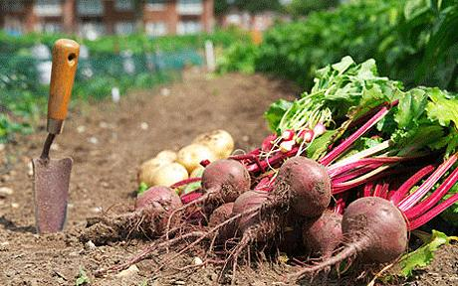

English focus:

Speaking and listening- interview someone who has grown their own fruit/ vegetables and what the process was.

Maths focus

Maths focus

Find out the food miles travelled for the ingredients of your evening meal.

Maths focus

Go to a local supermarket and find out the price of different fruit and vegetables.

Creative focus- computing

Collect images from the internet to make a great visual montage.

Creative focus

Plant different seeds and document how they grow!

Creative focus

Design your own growing area in your garden.