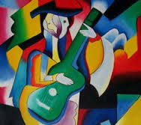

Creative focus

Practise drawing from observation. Choose a range of interesting objects to depict drawing pattern, shape and form.

Creative focus:

Make an abstract sculpture in the style of Dada artists. Explain your work to an adult and take a digital image so you can share it with others at school.

English focus

Choose a famous artist. Write a biography about the artist.

Include their early years and their famous artwork.

English focus

Create a persuasive advert for an Art Gallery. How will your Art Gallery be unique? What will it look like?

.

Creative focus:

Make a sketch book to use at home, use as many different types of paper as you can find.

Year Six

Maths focus

Create your own code using different colours for letters.

For example

Yellow might represent A.

Red might represent B

English focus

Research and write about different artists around the world. Create an information booklet about different artists.

Maths focus

Design and create your own co-ordinates map for an Art Gallery.

Maths focus

Draw and create your own artwork using different shapes and outlines!

Homework Menu

**Choose 3 homework tasks**