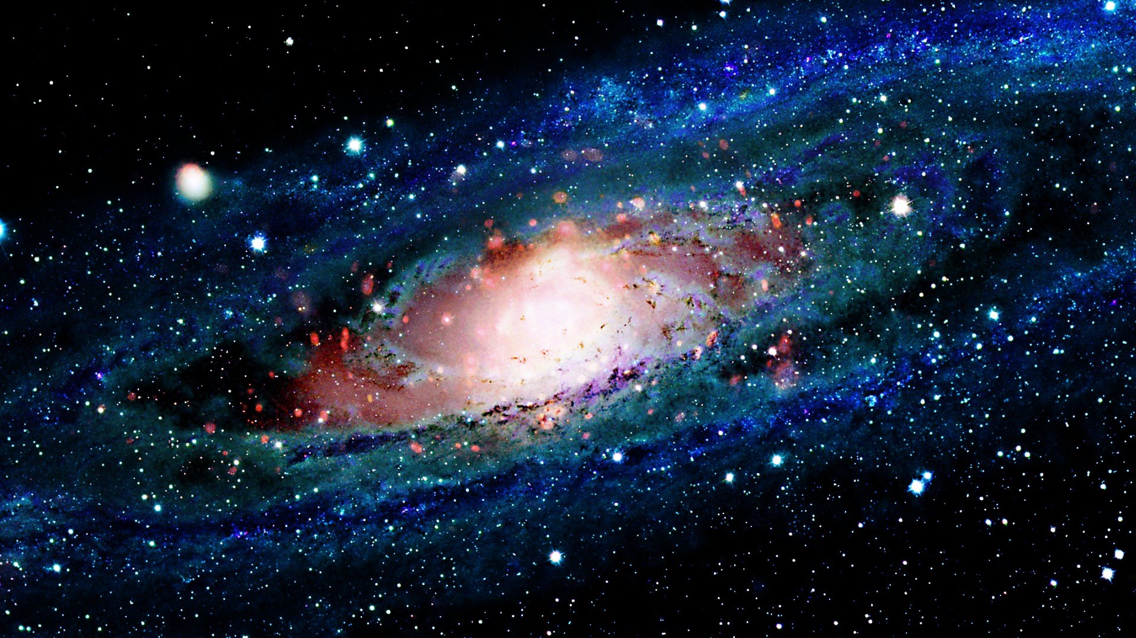

**Creative focus**

Make your own moon base using a shoe box-What would you need to have to live on the moon?

**Creative focus**

Choose a favourite space song to perform. Practise singing and adding actions and perform it to your family and friends!

**Maths focus**

Use 2D or 3D shapes to make a space ship-What shapes have you used? How many corners/vertices can you find?

**Maths focus**

Can you draw 3 aliens with different amounts of arms and eyes. How many arms are there all together? How many eyes??

**English focus**

Can you put the planets in alphabetical order?

**English focus**

Choose your favourite planet and make a fact file all about it.

**Maths focus**

Order the planets in our solar system in order of size - How big is the largest planet?

**Creative focus**

Could you design a new space suit for an astronaut? What would it look like? What features would it have?

**English focus**

Can you create your own space alien, and use adjectives in sentences to describe it?

Homework Menu

Choose 3 homework tasks