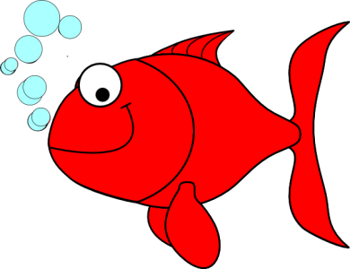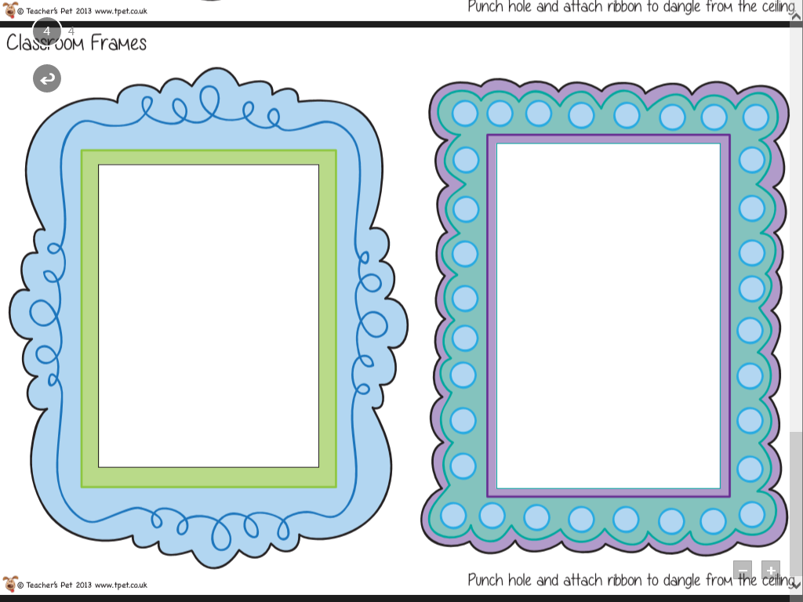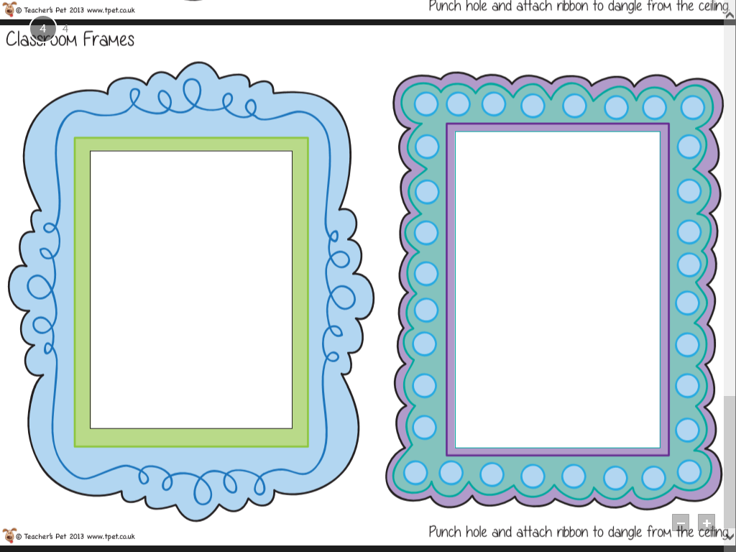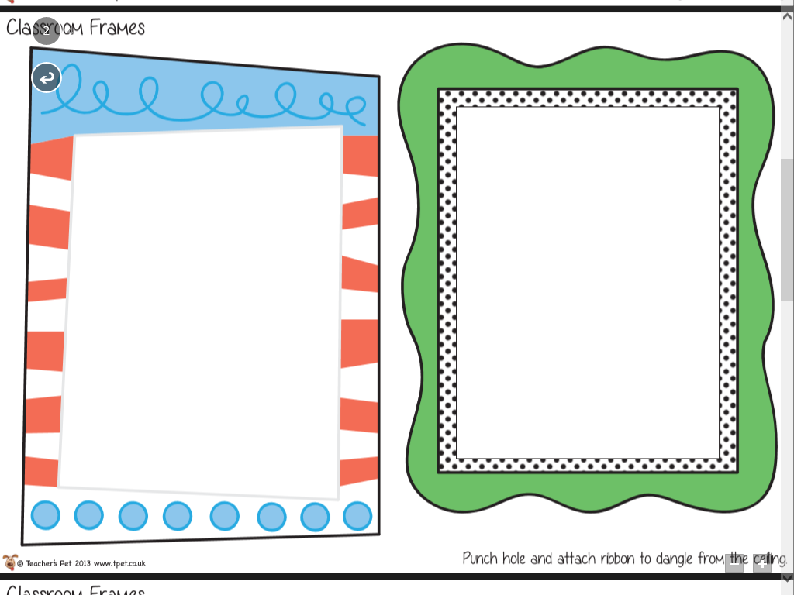

Choose **one activity** to complete for your homework project. Remember to present your work nicely!

**Homework due back:**

**Friday 5th April**

CREATE

Can you design, make or draw your own underwater sea creature? What will it look like? What will its name be?

RESEARCH

Research an underwater animal. It could be a shark, a jellyfish or a scary deep sea creature! Include pictures and lots of facts and information. Could you present it as a PowerPoint, poster or factfile?

WRITE

Write a poem about the creatures living in the blue abyss. It might be an acrostic, shape, haiku, cinquain or free verse poem.