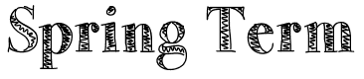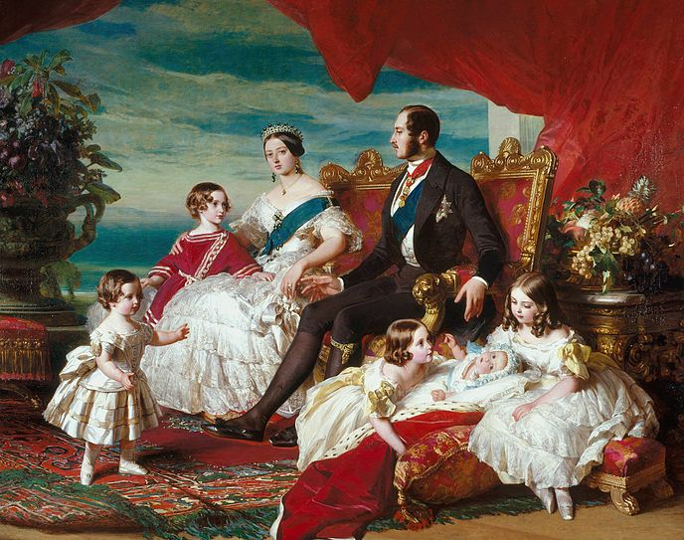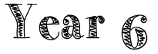  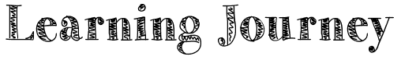

**PE**

PE will be on Monday each week. Please ensure PE kits and water bottles are in school on these days.

**Homework**

Homework will be issued on Tuesday and should be returned on Monday.

**Memorable Experience:**

We will be enjoying a whole day of being transported back to the Victorian Era by visiting the Black Country Living Museum.

**English:**

This term, we will be studying the novel ‘Street Child’ by Berlie Doherty. It is a fictional account of the experiences of Jim Jarvis, a young orphan who escapes the workhouse in 1860's London and survives brutal treatment and desperate circumstances until he is taken in by Dr. Barnardo, founder of a school for the city's "ragged" children. Our writing will be based on this looking at a variety of genres.

**Maths:**

In Maths this term, we will be securing our knowledge of fractions, decimals and percentages and using these skills to apply them to problem solving contexts. We will also be revising place value and the four operations through test style questions.

**History:**

We will be learning all about the Victorian Era and the living conditions for this. We will look at the life of Queen Victoria during her reign, significant Victorian inventions, crime and punishment, social economic class and the Industrial Revolution.

**Geography:**

We will be looking at significant locations during the Industrial Revolution and placing these on a map. We will also study the importance of transportation during the Industrial Revolution.

**RE:**

We will be looking at what we can learn from religion about temptation

**Art and Design:**

We will be looking at significant Victorian artists such as William Morris and creating our own block prints in this style. We will also be studying the work of Sir David Wilkie.

**Design and Technology:**

We will be following a recipe for and making traditional Victorian bread. We will also use textiles skills to create a Victorian clothes peg dolly.

**Science:**

During this topic we will be revising electricity and looking at the invention of the lightbulb.