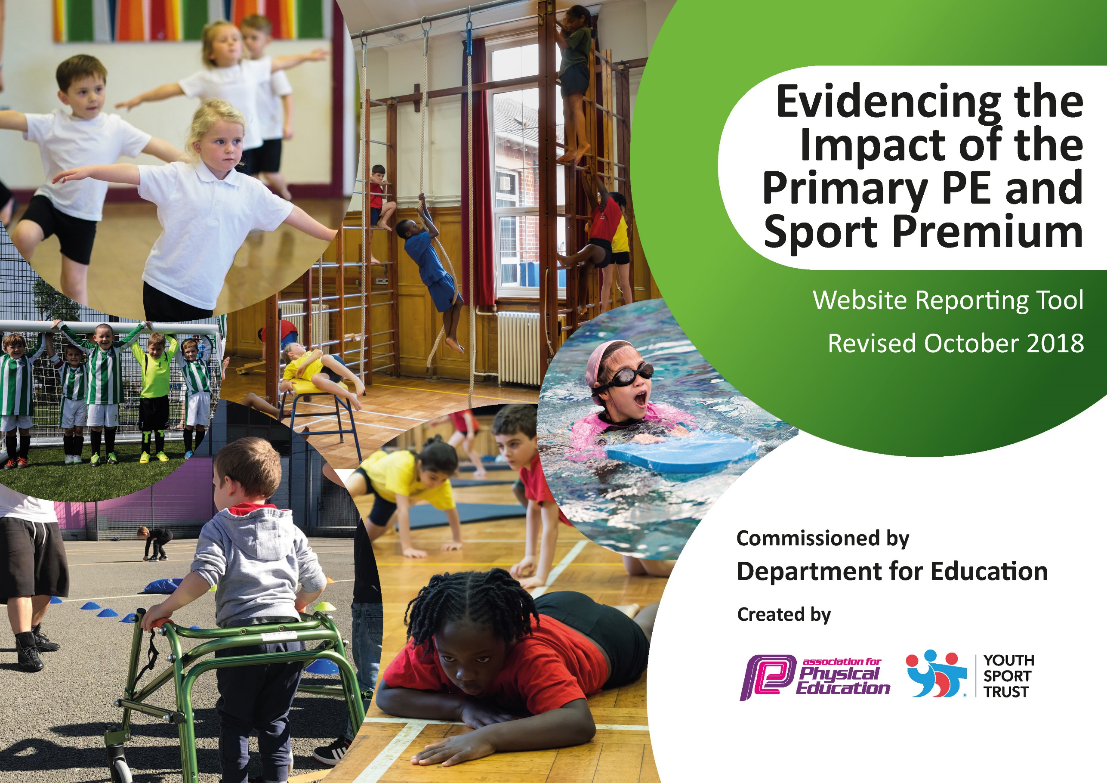
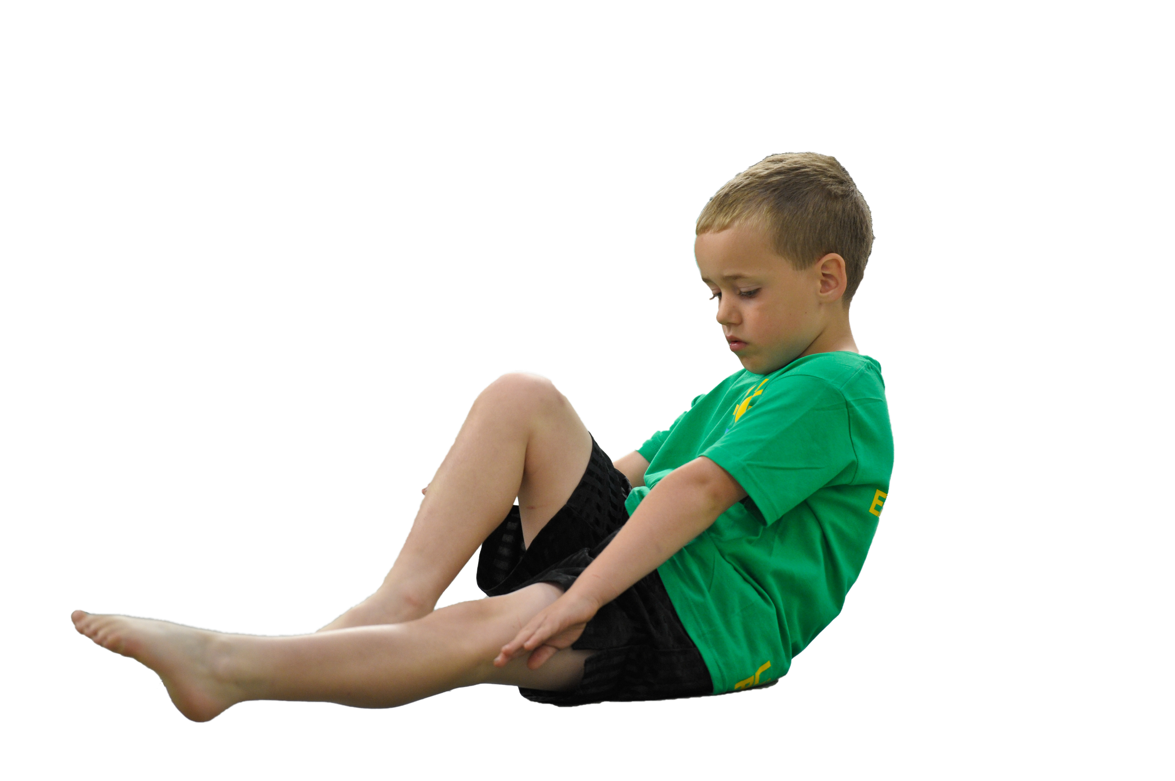
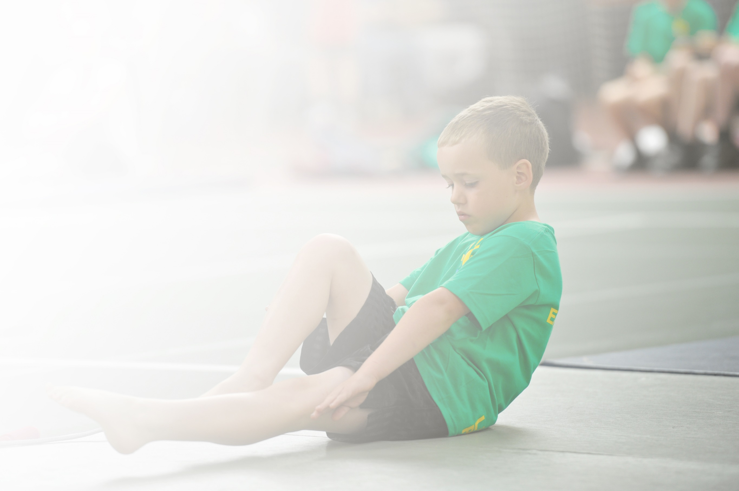
Schools must use the funding to make additional and sustainable improvements to the quality of Physical Education, Sport and Physical Activity (PESPA) they offer. This means that you should use the Primary PE and Sport Premium to:

- Develop or add to the PESPA activities that your school already offer
- Build capacity and capability within the school to ensure that improvements made now will benefit pupils joining the school in future years

Please visit gov.uk for the revised DfE guidance including the 5 key indicators across which schools should demonstrate an improvement. This document will help you to review your provision and to report
your spend. DfE encourages schools to use this template as an effective way of meeting the reporting requirements of the Primary PE and Sport Premium.

We recommend you start by reflecting on the impact of current provision and reviewing the previous
spend. Under the Ofsted Schools Inspection Framework, inspectors will assess how effectively leaders use the Primary PE and Sport Premium and measure its impact on outcomes for pupils, and how effectively governors hold them to account for this.

Schools are required to publish details of how they spend this funding as well as on the impact it has on pupils’ PE and sport participation and attainment by the end of the summer term or by 31 July 2019 at the
latest.
We recommend regularly updating the table and publishing it
on your website throughout the year, as evidence of your
ongoing review into how you are using the money to
secure maximum, sustainable impact. To see an
example of how to complete the table please
click HERE.

Support for review and reflection - considering the 5 key indicators from DfE, what development needs are a priority for your setting and your students now and why? Use the space below to reflect on previous spend, identify current need and priorities for the future.

Areas for further improvement and baseline evidence of need following leftover funding due to Covid 19 in the academic year 2020-2021:
With the carry forward of the Primary PE and Sports Premium, balancing the time left in the academic year 2020-2021 upon March 8th reopening with the resources ‘safely’ available to best meet our pupils needs, we will endeavour to continue with the following carry forward to best insure the following needs are met;
- Continue educating to address obesity and healthy lifestyles
- Continue to provide equipment to enhance outdoor activity and create opportunities for wider and further daily physical exercise both in and out of the school day
- Subsidise, where appropriate, extra-curricular activities
- To continue to promote sporting activities within school;
- To improve parental involvement in healthy and active lifestyles, healthy eating sessions

If Sports funding is extended once again for the academic year 2021-2022, this plan will be strengthened and expanded to meet further needs than currently planned.

Action Plan and Budget Tracking
Capture your intended annual spend against the 5 key indicators. Clarify the success criteria and evidence of impact that you intend to measure to evaluate for students today and for the future.

Academic Year: 2021/22 | Total fund allocated: £5070 carry forward (Possible Sports premium of £19570 TBC by Government)  Total fund spent: £ | Date Updated: 8th March 2021
Key indicator 1: The engagement of all pupils in regular physical activity – Chief Medical Officer guidelines recommend that primary school children undertake at least 30 minutes of physical activity a day in school |  |  |  | Percentage of total allocation:
 |  |  |  | %
School focus with clarity on intended impact on pupils: | Actions to achieve: | Funding allocated: | Evidence and impact: | Sustainability and suggested next steps:
- 1.1 Improve active engagement of all pupils in regular physical activity within lunch and breaks times | 1.1. Introduce a daily mile (Lead by designated staff member)for children to use at lunchtimes and other times during the day.  1.2. Establish playground track marking with playground markings. | £1500
Key indicator 2: The profile of PESSPA being raised across the school as a tool for whole school improvement |  |  |  | Percentage of total allocation:
 |  |  |  | %
School focus with clarity on intended impact on pupils: | Actions to achieve: | Funding allocated: | Evidence and impact: | Sustainability and suggested next steps:
2.2Healthy eating workshops | 2.2Children to take part in healthy eating workshops to improve understanding of sugar, fat and daily life choices when eating  27% of children in reception are overweight or obese, this increases to 45.7% in Year 6.  Providing children with information about how to lead a healthy active lifestyle will help to decrease the number of children who are obese or over weight.  Health Ambassadors, supported by the School nurse raise awareness with peers around making healthy choices | £196 |  | .
Key indicator 3: Increased confidence, knowledge and skills of all staff in teaching PE and sport |  |  |  | Percentage of total allocation:
 |  |  |  | %
School focus with clarity on intended  impact on pupils: | Actions to achieve: | Funding  allocated: | Evidence and impact: | Sustainability and suggested  next steps:
- 3.1Increased confidence, knowledge and skills of staff in teaching PE | 3.1 PE leads to Undertake AFPE Level 5 qualification  Joined AFPE (School Membership) to ensure access to specialist and expert support, thus keeping the school fully up to date. | £2000  £115 | .

Key indicator 4: Broader experience of a range of sports and activities offered to all pupils |  |  |  | Percentage of total allocation:
 |  |  |  | %
School focus with clarity on intended  impact on pupils: | Actions to achieve: | Funding  allocated: | Evidence and impact: | Sustainability and suggested  next steps:
- 4.1 A range of sporting extra-curricular activities offered to all children, including fencing, dodgeball and Archery  - 4.2 Year 6 visit to Outdoor Learning Centre | 4.1 External providers engage to offer a wide range of extra-curricular activities not possible to deliver in school.  4.2 All year 6 children (possibly Y5) to attend subsidised Woodlands Outdoor Learning Centre to engage in a variety of activities including assault course, paddle sports, archery, raft building. | £300  £500
Key indicator 5: Increased participation in competitive sport |  |  |  | Percentage of total allocation:
 |  |  |  | %
- 5.1 Increase participation in competitive sport | 5.1 Work alongside local schools and leagues to enter competitive sport in a range of sports included but not limited to tennis, football, netball Dodge ball. Opportunities advertised through the local learning community. | £200 | .

